Steps to create quality profiles:

1. Go to quality profiles section and click on Create tabs

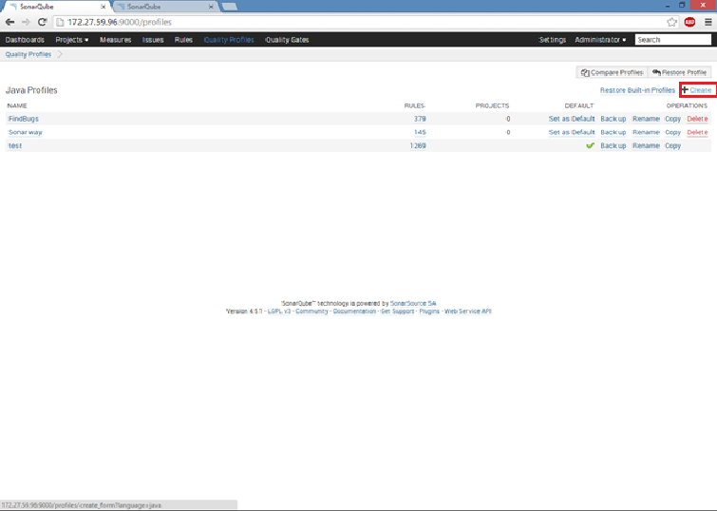

2.Give profile name and hit on Create tab

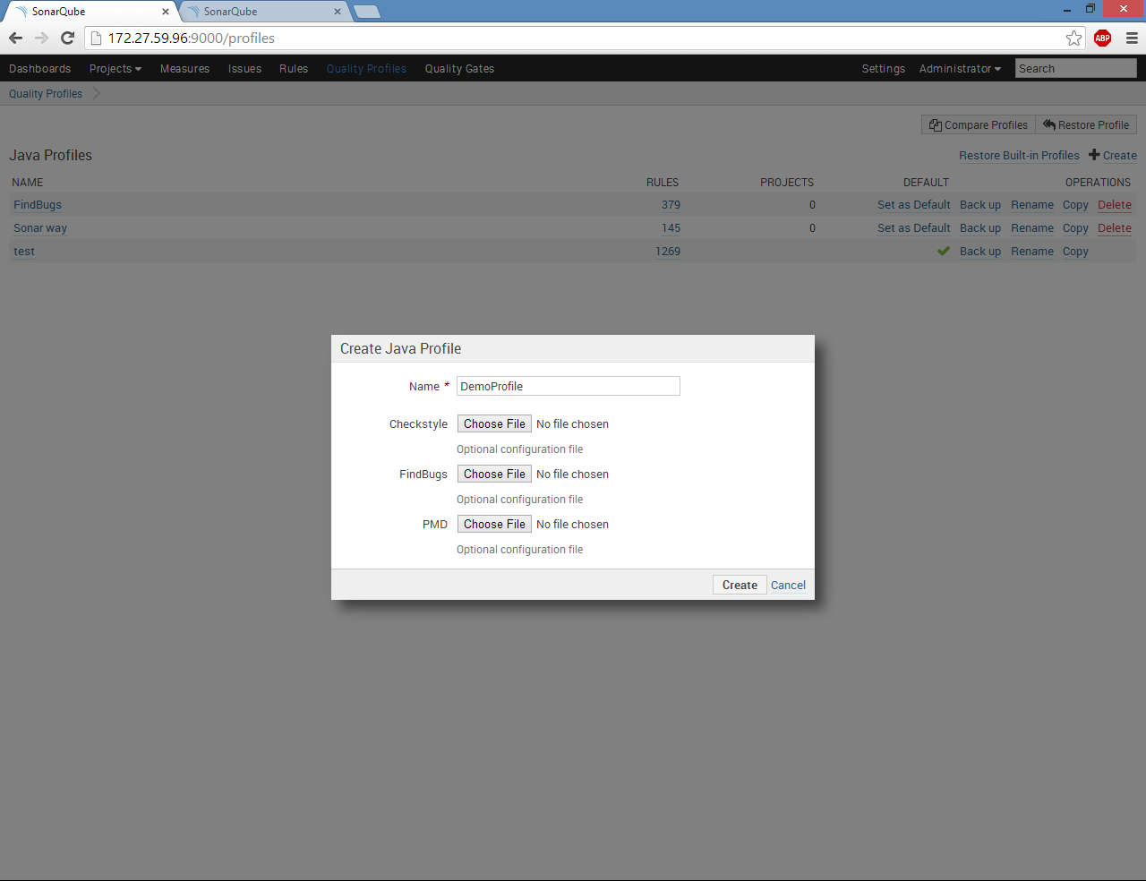

3. Now go to rules section activate all the available rules in the created profile (you can deactivate any specific rules)

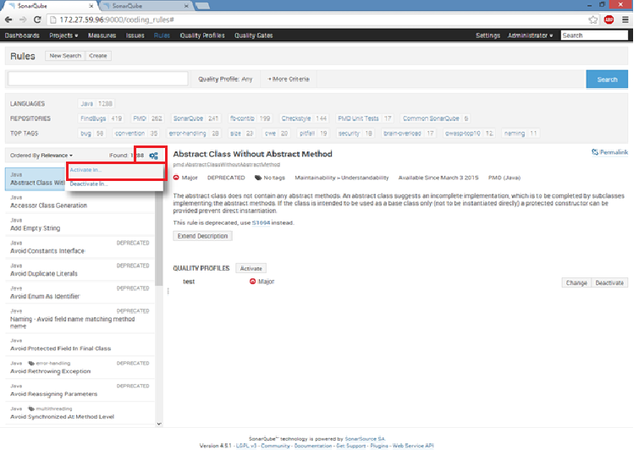

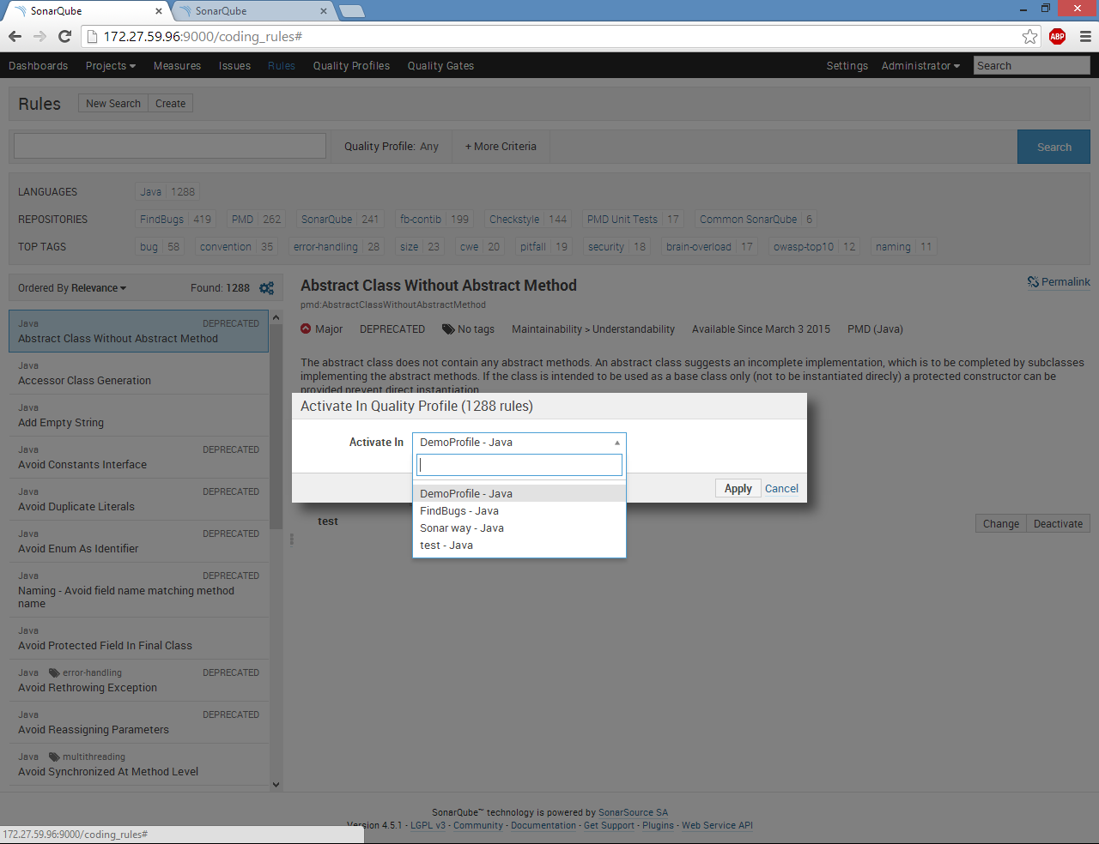

4. Go to Quality profiles section and set the created profile as a default profile

